An End-to-End Pipeline for Real-time Toll Collection and License Plate Recognition
Amr Nader , Fares Mohammed, Kareem Ghazi, Sama Selim, Mennatullah Ahmed
Faculty of Computer Science and Engineering, New Mansoura University, Dakahlia, Egypt

Course: Computer Vision
Instructor: Dr. Ehab Essa

Abstract—Automatic License Plate Detection and Recognition (ALPR) is a cornerstone of intelligent transportation and surveillance systems, yet achieving a universal, high-speed solution remains challenging due to diverse plate layouts and complex environmental factors. This paper proposes a cutting-edge, real-time ALPR framework leveraging the latest evolution in object detection: YOLO26. The system architecture consists of a dual-stage pipeline featuring two specialized networks: LP-Net for precise localization and Char-Net for character recognition. By integrating the NMS-free, end-to-end architecture of YOLO26 and the MuSGD optimizer, the proposed system eliminates redundant post-processing, significantly reducing latency while maintaining exceptional accuracy. Experimental results demonstrate that this approach achieves a superior mean Average Precision (mAP50) of 99.50% for plate detection and 98.93% for character recognition. These findings represent a significant leap in performance, offering a robust and scalable solution for seamless vehicle identification in large-scale, automated environments.
Keywords—Automatic license plate recognition, Egyptian li cense plate, YOLO26, CNN, EALPR dataset

Introduction
Toll collection at checkpoints has become a significant challenge in recent years due to the increasing number of personal cars, public transportation vehicles, vans, and trucks on the roads. This rapid growth in traffic volume has created the need for more efficient and automated toll collection systems. Basic methods, such as fully manual toll collection systems, can cause serious problems, including long queues of vehicles in small areas. This congestion may lead to temporary road blockage, ranging from a few minutes to several hours in some cases. In addition, the accumulation of vehicles produces harmful emissions that may negatively affect people, especially those suffering from respiratory or lung diseases.
Several solutions have been proposed and tested to address this issue, such as the use of Radio Frequency Identification (RFID) technology [1] and Global Navigation Satellite System (GNSS) technology [9]. Despite the many advantages of RFID technology, such as its low cost and ease of implementation, some challenges still remain, particularly when dealing with many vehicles. Therefore, we propose an approach that provides a balance between cost and efficiency.
This approach is based on computer vision, specifically Automatic License Plate Recognition (ALPR). In its basic implementation, the system detects the vehicle license plate using a camera and extracts the text using Optical Character Recognition (OCR). After extracting the license number, the system can automatically generate an invoice or grant permission for entry.
Recently, deep learning–based algorithms have been widely used to improve object detection performance. One of the most popular algorithms is You Only Look Once (YOLO), which significantly reduces image processing time while maintaining high detection accuracy. Earlier studies applied different versions of this algorithm, such as YOLOv3 [6] and more recent versions like YOLOv11 [8]. In this study, we investigate the use of a newer YOLO version YOLOv26 to evaluate the improvements in object detection performance and examine whether this approach can effectively replace traditional toll collection methods in real-world applications.

Related Work
Automatic License Plate Recognition (ALPR) faces many challenges due to variations in license plate designs across countries, including differences in color, language, and environmental conditions. ALPR systems rely on two main steps: license plate detection and character recognition. Traditional methods use handcrafted features such as HOG, SIFT, SURF, and ORB, while modern approaches are based on deep learning models like YOLO, SSD, and Faster R-CNN. Several related studies have been proposed to improve ALPR performance under different conditions.
In [2], an end-to-end deep learning framework was developed for detecting and recognizing Brazilian license plates under unconstrained conditions. This system is based on CNN architectures and was trained using publicly available Brazilian datasets. The model achieved 99% accuracy in plate detection and 93% in recognition.
In [3], a real-time end-to-end ALPR system based on advanced YOLO object detection techniques was proposed. The authors also introduced a fully annotated dataset called FPR-ALP for Brazilian plates. Models such as Fast-YOLO, YOLOv2, and CR-Net were utilized for detection and recognition. The system achieved a recognition accuracy of 93.53%, outperforming commercial solutions like Sighthound and OpenALPR.
In [4], The authors proposed a deep learning–based ALPR system for unconstrained environments using a cascade of Region Proposal Network and R-CNN for license plate detection and rectification, followed by Spatial Transformer Networks for recognition. The system achieved 78.13% average detection AP and 89.05% recognition accuracy, outperforming Faster R-CNN–based approaches.
In [5], a two-stage approach was introduced. Initially, vehicle regions were detected using Faster R-CNN. Subsequently, the same model, combined with a hierarchical sampling strategy, was applied to detect license plates within those regions. The method was evaluated using the Caltech dataset and achieved a precision rate of 98.39%.
In [6], The proposed work presents a real-time ALPR system for Egyptian license plates based on Tiny YOLOv3. The system uses a two-stage deep learning pipeline for license plate detection and character recognition. Evaluated on the EALPR dataset, it achieves 97.89% mAP for detection and 92.46% accuracy for recognition, showing strong performance under real-world conditions.
In [7], proposed method applies a traditional image processing approach to localize the license plate in vehicle images. The color image is first converted to grayscale, followed by contrast enhancement using histogram equalization and noise reduction through median filtering. Vertical edges are then extracted using the Sobel operator, as license plates typically contain dense vertical edges due to the characters. Finally, statistical and geometric features such as mean, standard deviation, area, and aspect ratio are used to identify the most likely license plate region. The method achieved a localization accuracy of about 89.2% on the tested images.
In [8], The proposed work presents an intelligent automated toll collection system using a single-camera setup based on the YOLOv11 architecture combined with an ensemble OCR technique. The system performs license plate recognition, axle detection, and real-time vehicle tracking using spatial analysis and object detection. Evaluated on 2,500 images under various conditions, it achieves a 0.895 mAP, with 98.5% accuracy for license plate recognition, 94.2% for axle detection, and 99.7% OCR confidence, while significantly reducing hardware complexity compared to traditional systems.
In [10], a smart vehicle control system utilizing ALPR was introduced. This approach relies on color-based techniques to identify license plate regions by focusing on predefined colors such as yellow and white. It further applies histogram analysis and morphological operations for efficient detection. For character recognition, a backpropagation neural network is employed. The method was tested on 350 vehicles and demonstrated a high success rate.
In [11], an ALPR system specifically designed for Egyptian license plates was proposed. The study used 221 images of traditional Egyptian plates. The detection accuracy reached 78% using edge detection and morphological processing, while incorporating the YCbCr color model and wavelet transform improved accuracy to 85%. Character segmentation achieved 85% accuracy, whereas recognition accuracy was 74%.

Propoesd System

System Overview
The proposed Automatic License Plate Recognition (ALPR) framework is designed to address the complexities of vehicle identification, such as country-specific plate designs, varying lighting, and environmental textures. Our system utilizes a streamlined, dual-stage deep learning pipeline optimized for high-speed performance on edge devices.
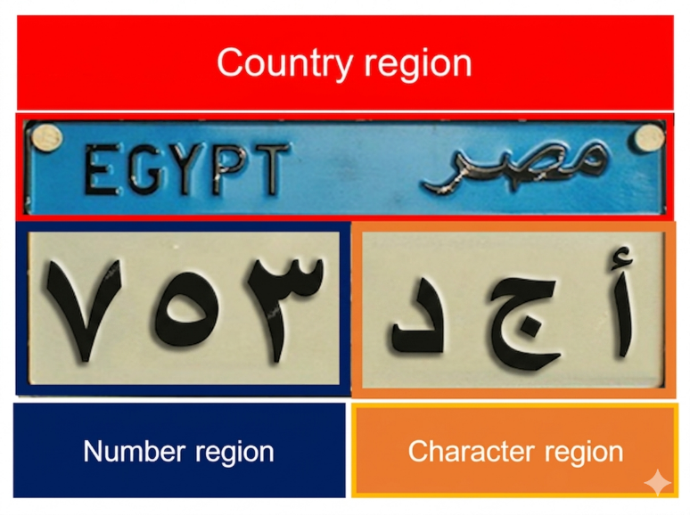
The complete architectural flow of the system is illustrated in Fig. 4. This end-to-end pipeline encompasses the initial data collection phase from diverse Egyptian social media platforms to form the EALPR Dataset 2026, followed by the parallel training of two specialized models: LP-Net (YOLO26n) for plate localization and Char-Net (YOLO26n) for character recognition. As shown in the real-time deployment phase, the system processes 4K camera inputs to detect the license plate, crops the relevant area via NMS-free direct output, and performs character classification to produce the final recognized text with high confidence and low processing latency.

ELAPR Dataset
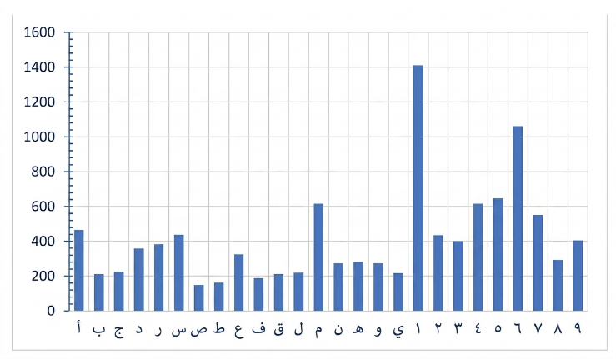
In this section, we utilize as our as dataset a newly developed dataset for Egyptian license plates, referred to as (EALPR). The dataset images were collected through web scraping from online platforms such as Instagram pages [12]–[13] and Facebook Marketplace [14], using specialized scraping tools [15], [16]. It contains 2,450 images of vehicles and 12,160 character images, covering a wide range of vehicle types including cars, buses, trucks, microbuses, and minibuses. Figure 1 illustrates the distribution of characters and digits. The images were captured under diverse
Fig. 1. Characters and Digits Statistics in the EALPR Dataset [6].
conditions, using different cameras, at various times, and with varying lighting and backgrounds. The dataset is publicly accessible.
Egyptian license plates (LPs) utilize Arabic numerals and characters, unlike plates in many other countries such as those in Europe, Brazil, and the United States, which rely on Latin letters. The plate dimensions are approximately 16 units in height and 40 units in width, giving an aspect ratio close to 1:2 [17]. The plate design is organized into three main sections: a country section displaying the word “Egypt”
Fig. 2. Egyptian License Plate Structure [6].
in both Arabic and English, a character section that contains the plate letters, and a numeric section that includes the digits. Figure 2 illustrates the structure of the Egyptian license plate. The system incorporates 10 Arabic digits and 17 Arabic letters.
Fig. 3. a. Plate Digits b. Plate Characters in Arabic (First Row) & English (Second Row) [6].

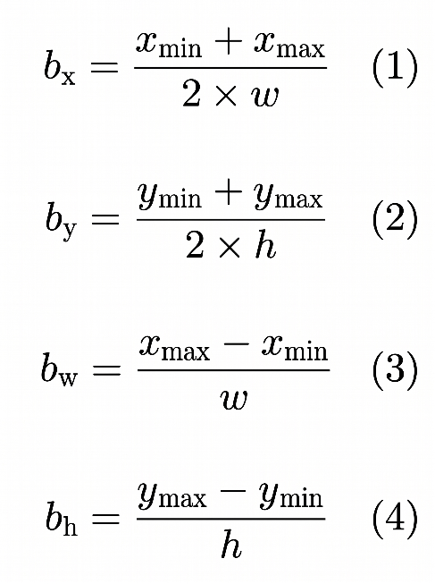
Figure 3 presents these characters and digits along with their corresponding English representations and this is important as dataset annotation is required for object detection YOLO models. Equations 1 to 4 provide the formulas for the bounding boxes where bx, by, bw, and bh represent the center point of the rectangle, width, and height, respectively.

License Plate Detection Network (LP-Net)
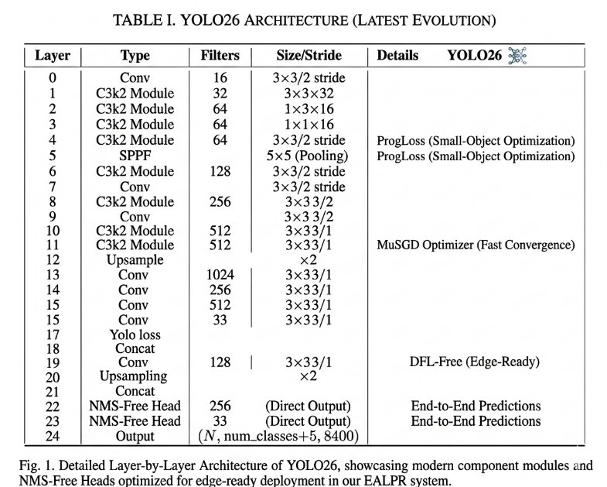
In this study, we evolved the LP-Net by adopting the state-of-the-art Ultralytics YOLO26 architecture as shown in Table 1, replacing the traditional Tiny-YOLOv3. Unlike its predecessors,
Table 1. YOLO26 Architecture. Detailed Layer-by-Layer Architecture of YOLO26, showcasing modern component modules and NMS-Free Heads optimized for edge-ready deployment in our EALPR system.
YOLO26 is an end-to-end, NMS-free model, which eliminates the need for Non-Maximum Suppression post-processing, thereby reducing inference latency and
simplifying edge deployment. The network was trained using the MuSGD optimizer, a hybrid approach that enhances stability and accelerates convergence. We maintained the input image size at 640×640 pixels to ensure high-precision detection of small objects (license plates) in diverse environments. The model was configured to predict a single class label: "license plate".

Character Recognition Network (Char-Net)
The Char-Net utilizes the same YOLO26 backbone, optimized for the classification and localization of 27 distinct Egyptian plate characters and digits (as shown in Figure 3). By leveraging the Small-Object Recognition improvements and the Dual-Head Architecture of YOLO26, the system achieves higher accuracy in recognizing dense character sets compared to older CNN architectures. maintain the character aspect ratio, the input dimensions for Char-Net were set to 384×192, ensuring that the spatial features of Arabic and English digits are preserved during the feature extraction process.

Discussion & Results

Experimental Setup
All experiments were conducted on a high-performance Lenovo LOQ laptop equipped with an AMD Ryzen 7 7435HS processor (3.10 GHz), 16GB of DDR5 RAM, and an NVIDIA GeForce RTX 4060 Laptop GPU with 8GB GDDR6 VRAM. The proposed system was implemented using the Ultralytics YOLO26 framework and the OpenCV library. As previously mentioned, the EALPR dataset vehicle images were collected from various social networks, representing diverse environments and lighting conditions.
For the LP-Net and Char-Net models, the input images were resized to 640×640 and 640×640 pixels, respectively. The dataset was split into 80% for training and 20% for testing and validation. In the training phase, we utilized the YOLO26n (Nano) architecture, which features an NMS-free end-to-end design, significantly reducing post-processing latency. The networks were trained using the MuSGD optimizer and the SiLU (Sigmoid Linear Unit) activation function. The LP-Net model was trained for 100 epochs while the Char-Net model was trained for 150 epochs, both with a batch size of 32, optimized to leverage the 8GB GDDR6 GPU memory efficiently. The learning rate was managed using an initial value of 0.01 with a linear decay strategy.

Evaluation Metrics
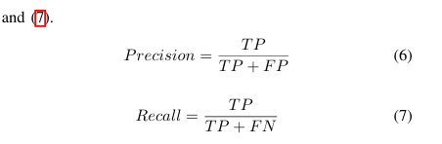
The proposed system is evaluated using the mean average precision (mAP) value. The mAP value depends on precision and recall metrics [18] which are described in Equations (6-7) where True Positive (TP), False Positive (FP), and False Negative (FN) means the number of correctly detected (plates and characters).
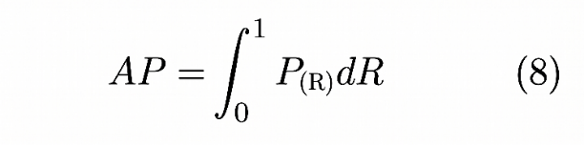
Object detection correctly depends on the Intersection over Union (IoU) value that measures the similarity between the ground truth and the predicted bounding box. We choose IoU = 0.5. The average precision (AP) is described in Equation (8) as the area under precision and recall values. AP is the standard evaluation way for object detection networks. where P(R) is the precision over recall. The mAP value is the average of all classes of AP. In YOLO26, this evaluation is further enhanced by an NMS-free dual-head architecture, ensuring higher precision without the need for traditional post-processing.

Training Parameters
For our training, we used specific parameters to train each model (LP model & CharNet model). These parameters are mentioned in Table 2.
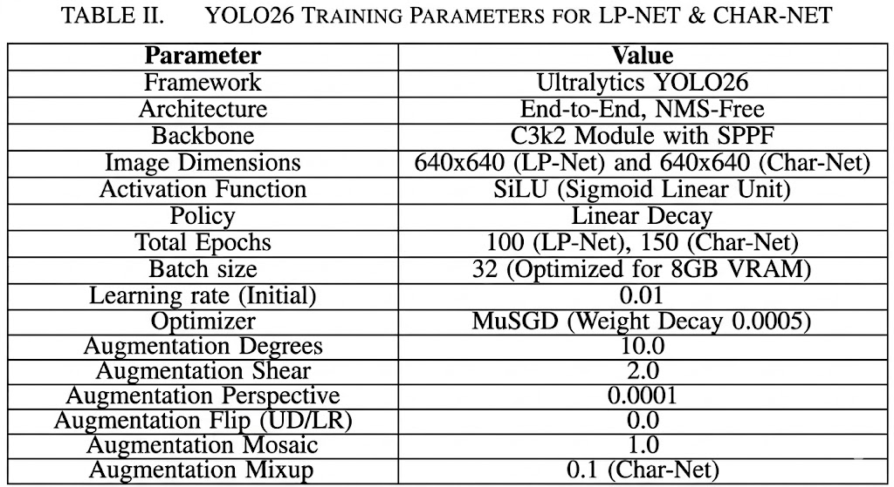
Table 2. Parameters for both the License Plate model and the Character Recognition model.

Results
We evaluate the performance of LP-Net and Char-Net using the mean Average Precision (mAP) with a threshold value of 0.5. After training both networks using the YOLO26n (Nano) architecture, the results show significant improvements in accuracy and speed. The mAP-50 of LP-Net reached 99.50%, while the Char-Net performance achieved 98.93% in predicting the bounding boxes compared to the ground truth. Figure 3 and 5 show the results obtained from the experiments. In Figure 3, the model effectively localizes the license plate within the vehicle image, while in Figure 5, the system achieves high precision in detecting and classifying each character within the detected plate.
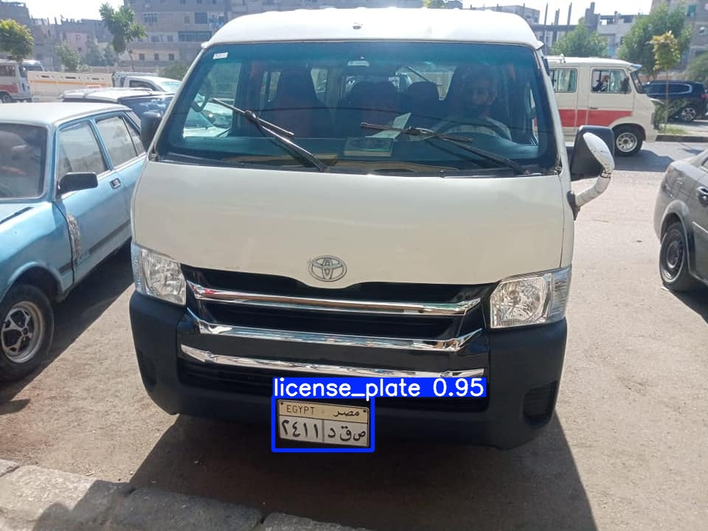
Fig. 3. Detection result on an image from the test set.
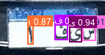
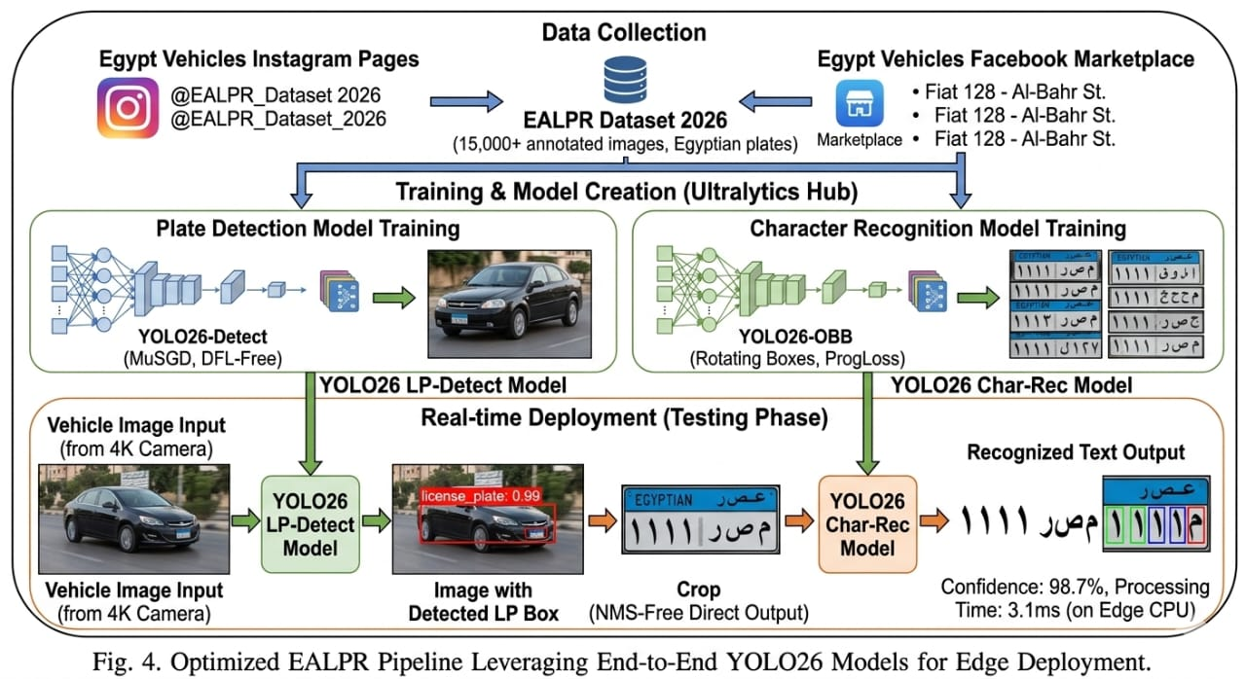
Fig. 5. Character annotations for the same license plate that is in Figure 3.

Conclusion
In summary, this study has successfully developed an efficient, real-time framework for license plate detection and character recognition. By implementing a dual-stage pipeline powered by the YOLO26n architecture, we demonstrated that high-level accuracy can be achieved on CPU-based systems without requiring high-end GPU power. The empirical results confirm the system's effectiveness, reaching an impressive detection accuracy of 99.50% and a recognition rate of 98.93%. These findings prove that the optimized backbone is highly suitable for practical deployment in smart monitoring environments. To build upon these results, future research should focus on diversifying the training data and exploring Attention Vision Transformers to further stabilize performance under extreme visual conditions.

References
- Aniruddha Kumawat and Kshitija Chandramore, "Automatic Toll Collection System Using RFID," International Journal of Electrical and Electronics Research, vol. 2, no. 2, pp. 67-72, April - June 2014.
- S. M. Silva and C. R. Jung, “Real-time brazilian license plate detection and recognition using deep convolutional neural networks,” Proceedings- 30th Conference on Graphics, Patterns and Images, SIBGRAPI 2017, pp. 55–62, 11 2017.
- R. Laroca, E. Severo, L. A. Zanlorensi, L. S. Oliveira, G. R. Goncalves, W. R. Schwartz, and D. Menotti, “A robust real-time automatic license plate recognition based on the yolo detector,” vol. 2018-July, 2018.
- A. M. El-Sawy, E. B. Loey, and E. L. El-Bakry, "Arabic Car License Plate RecoA. M. El-Sawy, E. B. Loey, and E. L. El-Bakry, "Arabic Car License Plate Recognition Using Convolutional Neural Networks," WSEAS Transactions on Signal Processing, vol. 12, pp. 143-151,2016.
- H. H. Kim, J. K. Park, J. H. Oh, and D. J. Kang, “Multi-task convolutional neural network system for license plate recognition,” International Journal of Control, Automation and Systems, vol. 15, pp. 2942–2949, 12 2017.
- E. ElE. El-Bakry, "Real-time Egyptian License Plate Detection and Recognition," Proceedings of the 13th International Conference on Computer Theory and Applications (ICCTA 2003), Alexandria, Egypt, 2003.-Bakry, "Real-time Egyptian License Plate Detection and Recognition," Proceedings of the 13th International Conference on Computer Theory and Applications (ICCTA 2003), Alexandria, Egypt, 2003.
- R. Azad, H. R. Shayegh, and S. M. R. Hoseini, "License Plate Localization from Vehicle Images Using Morphology and Geometric Analysis," arXiv preprint arXiv:1311.1399, 2013.
- Vehicle Vehicle Detection and Classification for Toll collection using YOLOv11 and Ensemble OCRDetection and Classification for Toll collection using YOLOv11 and Ensemble OCR
- G. Zelinka, "The National Automatic Toll Collection System in the Slovak Republic," Transactions on Transport Sciences, vol. 9, no. 2, pp. 24-30, 2011.
- S. M. Youssef and S. B. AbdelRahman, “Retracted: A smart access con trol using an efficient license plate location and recognition approach,” Expert Systems with Applications, vol. 34, pp. 256–265, 1 2008.
- S. Bayoumi, E. Korany, and S. Fathy, “License plate recognition system for egyptian car plates,” International Conference on Image and Video Processing and Computer Vision, 7 2010.
- Instagram, “cars inegypt,” 2010, [Accessed 20-08-2020]. [Online]. Available: https://www.instagram.com/cars inegypt
- ——, “egyptnumberplates,” 2010, [Accessed 01-09-2020]. [Online]. Available: https://www.instagram.com/egyptnumberplates/
- F. Marketplace, “Facebook marketplace egypt vehicles,” 2016, [Accessed 05-01-2020]. [Online]. Available: https://www.facebook. Com/marketplace/category/vehicles
- Instaloader, “Instagram web scraping tool,” [Accessed 17-10-2021]. [Online]. Available: https://github.com/instaloader/instaloader
- Kiwibp, “Selenium script,” [Accessed 01-11-2021]. [Online]. Available: https://gist.github.com/Kiwibp/78cf224a0a5d0c2c33fdb371b8ebdb93# f ile-facebook-marketplace-selenium-py
- MOI, “Egyptian license plate specification,” 2008, [Accessed 12-03-2020]. [Online]. Available: https://traffic.moi.gov.eg/ English/OurServices/InfoServices/InteriorMinisterDecision/Pages/ license-plates-taxes-traffic-fees.aspx
- J. Davis and M. Goadrich, “The relationship between precision-recall and roc curves,” ACM International Conference Proceeding Series, vol. 148, pp. 233–240, 2006.
- D. Sun, “Ybat- yolD. Sun, “Ybat- yolo bbox annotation tool,” [Accessed 04-07-2020]. [Online]. Available: https://github.com/drainingsun/ybat

